**66.**

#include <iostream>

using namespace std;

int main ()

{

char ans_3598; //repeatition_loop

do

{

int size_3598=0;

cout<<"Please_ENTER_how_many_numbers_you_will_input: ";

cin>>size_3598;

int input_3598[size_3598]; //store_the_array;

cout<<"Please_ENTER_the_numbers: "<<endl;

for (int i_3598=0; i_3598<size_3598; ++i_3598) //loop_for_array_number;

{

cin>>input_3598[i_3598];

}

//I_start_the_loop_for_determination_of_the_same_numbers

int max_count_3598=0, max_num_3598, count_3598;

for (int p_3598=0; p_3598<size_3598; p_3598++)

{ count_3598=1;

for (int z_3598=p_3598+1; z_3598<size_3598; z_3598++)

{

if (input_3598[p_3598]-input_3598[z_3598]==0) //repeated_number

{

count_3598=++count_3598; //counter_starts

}

}

if (max_count_3598<count_3598)

{

max_count_3598=count_3598;

max_num_3598=input_3598[p_3598];

}

}

if (max_count_3598==1)

{

cout<<"NO_most_repeated_number!"<<endl;

}

else

{

cout<<endl<<"The_most_repeated_number_is_: "<<max_num_3598<<endl;

}

cout<<"Would_you_like_to_repeat_trial?"<<endl;

cin>>ans_3598;

cout<<endl;

}

while (ans_3598=='Y' || ans_3598=='y');

return 0;

}

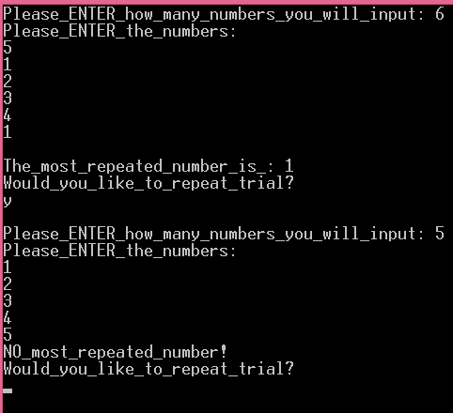

**67.**

#include <iostream>

using namespace std;

int main ()

{

char ans_3598; //repeatition_loop

do

{ int array_size_3598=0;

int array_3598[array_size_3598];

cout<<"_Please_enter_how_many_numbers_to_sort_: \n";

cin>>array_size_3598;

int size_store_3598=array_size_3598; //I_store_array_size

int size_2_3598=array_size_3598; //also_store_array_size

cout<<endl;

cout<<"and_now_enter_the_numbers_please:__";

for (int i_3598=0; i_3598<array_size_3598; ++i_3598)

{

cin>>array_3598[i_3598];

cout<<endl;

}

for (int z_3598=0; z_3598<size_store_3598; ++z_3598) //here_I_open_outer_loop;

{

for (int d_3598=0; d_3598<size_store_3598; ++d_3598) //inner_loop;

{

if (array_3598[d_3598]>array_3598[z_3598])

{

//now_if_the_condition_is_valid_I_change_them

int store_3598;

store_3598=array_3598[z_3598];

array_3598[z_3598]=array_3598[d_3598];

array_3598[d_3598]=store_3598;

}

}

}

cout<<"The_sorted_array_is_:"<<endl;

for (int p_3598=0; p_3598<size_2_3598; ++p_3598) //loop_for_the_output_

{cout<<array_3598[p_3598]<<endl;}

cout<<"Would_you_like_to_repeat_trial?"<<endl;

cin>>ans_3598;

cout<<endl;

}

while (ans_3598=='Y' || ans_3598=='y');

return 0;

}

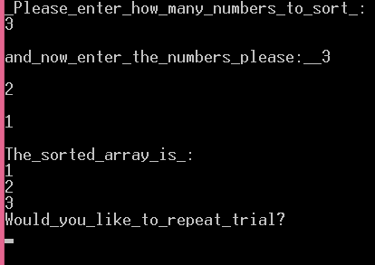

**68.**

#include <iostream>

using namespace std;

int main ()

{

char ans_3598; //repeatition_loop

do

{

int size_3598=0, num_3598[size_3598];

double sum_3598=0;

cout.setf(ios::fixed);

cout.setf(ios::showpoint);

cout.precision(3);

cout<<"Please_ENTER_how_many_numbers: ";

cin>>size_3598;

cout<<endl;

cout<<"Enter__the__numbers__: ";

for (int i_3598=0; i_3598<size_3598; ++i_3598)

{

cin>>num_3598[i_3598];

sum_3598+=num_3598[i_3598];

}

cout<<endl<<"Average__is_: "<<sum_3598/size_3598<<endl;

cout<<"Would_you_like_to_repeat_trial?"<<endl;

cin>>ans_3598;

cout<<endl;

}

while (ans_3598=='Y' || ans_3598=='y');

return 0;

}

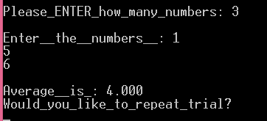

**69.**

#include <iostream>

using namespace std;

int main ()

{

char ans_3598; //repeatition_loop

do

{

int size_3598=0, num_3598[size_3598], max_3598, min_3598;

int a_3598;

cout<<"Please_ENTER_how_many_numbers: ";

cin>>a_3598;

cout<<endl;

cout<<"Enter__the__numbers__: ";

size_3598=a_3598; //I_store_the_value_of_array_size;

int b_3598=a_3598; //I_store_it_again_for_the_inner_for_loop_of_the_second_for_loop;

for (int i_3598=0; i_3598<size_3598; ++i_3598)

{

cin>>num_3598[i_3598]; //here_array_numbers_input;

}

for (int y_3598=0; y_3598<a_3598; ++y_3598) //comparison_between_numbers_start;

{

max_3598=num_3598[y_3598]; //I_assign_the_maximum_and_minimum_values_as_equal_to_initial_array_number;

min_3598=num_3598[y_3598];

for (int z_3598=0; z_3598<b_3598; ++z_3598)

{

if (min_3598>num_3598[z_3598]) //the_smallest_number_will_be_defined

{

min_3598=num_3598[z_3598];

}

else if (max_3598<num_3598[z_3598]) //the_biggest_number_will_be_defined

{

max_3598=num_3598[z_3598];

}} }

cout<<endl<<"MIN__is_: "<<min_3598<<endl;

cout<<"MAX_is: "<<max_3598<<endl;

cout<<"Would_you_like_to_repeat_trial?"<<endl;

cin>>ans_3598;

cout<<endl;

}

while (ans_3598=='Y' || ans_3598=='y');

return 0;

}

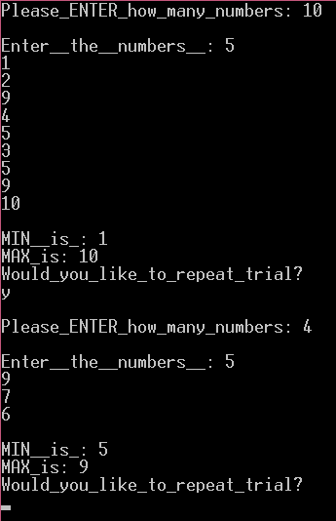

**70.**

#include <iostream>

using namespace std;

int main ()

{

char ans_3598; //repeatition_loop

do

{

int array_3598[4];

for (int i_3598=0; i_3598<4; ++i_3598)

{

cout<<"__Please_input_the_integer_number_: \n";

cin>>array_3598[i_3598];

cout<<endl;

}

for (int z_3598=0; z_3598<4; ++z_3598) //here_I_open_outer_loop;

{

for (int d_3598=0; d_3598<4; ++d_3598) //inner_loop;

{

if (array_3598[d_3598]>array_3598[z_3598])

{

//now_if_the_condition_is_valid_I_change_them

int store_3598;

store_3598=array_3598[z_3598];

array_3598[z_3598]=array_3598[d_3598];

array_3598[d_3598]=store_3598;

}

}

}

cout<<endl<<"The_sorted_array_is_:"<<endl<<array_3598[0]<<endl<<array_3598[1]<<endl<<array_3598[2]<<endl<<array_3598[3]<<endl;

cout<<"Would_you_like_to_repeat_trial?"<<endl;

cin>>ans_3598;

cout<<endl;

}

while (ans_3598=='Y' || ans_3598=='y');

return 0;

}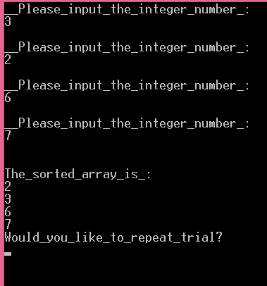

**71.**

#include <iostream>

using namespace std;

int main ()

{

char ans_3598; //repeatition_loop

do

{ int array_3598[4]; //array_with_size=4;

cout<<"Please_input_the_integer__v@lues_: "<<endl;

for (int i_3598=0; i_3598<4; ++i_3598 ) //the_loop_for_input_data;

{

cin>>array_3598[i_3598];

}

int store_2_3598=0; //I_store_the_value_of_array_3598[2];

int store_1_3598=0, store_0_3598=0;

store_0_3598=array_3598[0];

store_1_3598=array_3598[1];

store_2_3598=array_3598[2];

array_3598[1]=3; //second_number_should_be_3;

cout<<endl<<store_0_3598<<endl<<array_3598[1]<<endl<<store_1_3598<<endl<<store_2_3598<<endl;

cout<<"Would_you_like_to_repeat_trial?"<<endl;

cin>>ans_3598;

cout<<endl;

}

while (ans_3598=='Y' || ans_3598=='y');

return 0;

}

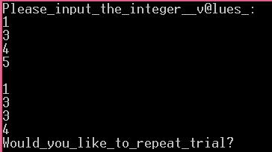

**72.**

#include <iostream>

#include <ctime>

#include <cstdlib>

using namespace std;

int main ()

{

char ans_3598; //repeatition_loop

do

{ int array_3598[10]; //array_declaration;

srand((unsigned)time(0));

for (int i_3598=0; i_3598<10; ++i_3598)

{

array_3598[i_3598]=1+rand()%50;

cout<<array_3598[i_3598]<<endl;

}

int num_3598;

cout<<"Please_input_the_value_you_want_to_find: ";

cin>>num_3598;

int n_3598=0; //counts_numbers

for (int z_3598=0; z_3598<10; ++z_3598)

{

if (array_3598[z_3598]==num_3598) //if_it_finds_similar_number

{

cout<<num_3598<<"_is_in_the_slot_# "<<z_3598+1<<endl;

n_3598=n_3598+1; //counts_for_the_purpose_not_to_display_another_condition

}

}

if (n_3598==0)

{

cout<<"The_value_is_not_within_the_array!\n";

}

cout<<"Would_you_like_to_repeat_trial?"<<endl;

cin>>ans_3598;

cout<<endl;

}

while (ans_3598=='Y' || ans_3598=='y');

return 0;

}

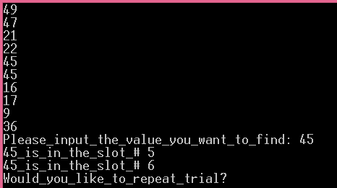

**73.**

#include <iostream>

using namespace std;

int main ()

{

char ans_3598; //repeatition_loop

do

{ int array_3598[10]; //array_declaration;

cout<<"____Please_input_10_numbers_: \n";

for (int i_3598=0; i_3598<10; ++i_3598) //loop_for_input;

{

cin>>array_3598[i_3598];

}

cout<<"Array__is: ";

for (int i_3598=0; i_3598<10; ++i_3598) //loop_for_display_the_array

{

cout<<array_3598[i_3598]<<" ";

}

int num_3598;

cout<<"\nPlease_input_the_value_you_want_to_find: ";

cin>>num_3598;

int n_3598=0; //counts_numbers

for (int z_3598=0; z_3598<10; ++z_3598)

{

if (array_3598[z_3598]==num_3598) //if_it_find_similar_number

{

n_3598=n_3598+1; //counts_for_the_purpose_not_to_display_another_condition

}

}

if (n_3598==0)

{

cout<<"The_value_is_not_within_the_array!\n";

}

else

{

cout<<num_3598<<"_was_found_"<<n_3598<<"times_!\n";

}

cout<<"Would_you_like_to_repeat_trial?"<<endl;

cin>>ans_3598;

cout<<endl;

}

while (ans_3598=='Y' || ans_3598=='y');

return 0;

}

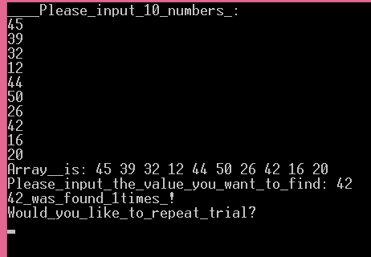

**74.**

#include <iostream>

using namespace std;

int main ()

{

char ans_3598; //repeatition_loop

do

{ int array_3598[10]; //array_declaration;

int large_3598;

cout<<"____Please_input_10_numbers_: \n";

for (int i_3598=0; i_3598<10; ++i_3598) //loop_for_input;

{

cin>>array_3598[i_3598];

}

for (int z_3598=0; z_3598<10; ++z_3598)

{

large_3598=array_3598[z_3598]; //I_assign_the_largest_value;

for (int p_3598=0; p_3598<10; ++p_3598)

{

if (large_3598<array_3598[p_3598])

{

large_3598=array_3598[p_3598];

}

}

} cout<<"the_largest_number_is: "<<large_3598<<endl;

cout<<"Would_you_like_to_repeat_trial?"<<endl;

cin>>ans_3598;

cout<<endl;

}

while (ans_3598=='Y' || ans_3598=='y');

return 0;

}

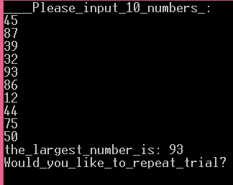

**75.**

#include <iostream>

#include <cctype>

using namespace std;

int main ()

{

char input_3598[50]={0};

cout<<"ENTER_the_first_array:__";

cin.getline(input_3598, 50);

cout<<endl;

char input2_3598[50]={0};

cout<<"ENTER_the_second_array:__";

cin.getline(input2_3598, 50);

cout<<endl;

int sum1_3598=0, sum2_3598=0;

int ch1_value_3598=0, ch2_value_3598=0; //declare_decimal_equivalent;

int a_3598=0;

int n_3598=0; //initialized_integer;

for( int i_3598=0; input_3598[i_3598]!='\0'; i_3598++) //

{

if (input_3598[i_3598]==input2_3598[i_3598])

{

n_3598=n_3598+1; //integer_will_increase_if_the_words_are_same_till_the_end_of_one_array

}

if (i_3598>0)

{

a_3598=i_3598+1; //I_will_need_that_vale_later_to_know_the_character_numbers_in_the_array;

}

}

for( int h_3598=0; input_3598[h_3598]!='\0'; h_3598++) //here_I_calculate_ASCII_for_first_input

{

ch1_value_3598=input_3598[h_3598]; //convert_the_character_to_ASCII;

sum1_3598+=ch1_value_3598;

}

for( int j_3598=0; input2_3598[j_3598]!='\0'; j_3598++) //in_that_loop_I_calculate_ASCII_for_second

{ ch2_value_3598=input2_3598[j_3598]; //convert_the_character_to_ASCII;

sum2_3598+=ch2_value_3598;

}

if (n_3598==a_3598 && n_3598!=0 && input_3598[50]==input2_3598[50])

{

cout<<"\n0"; //display_zero_if_the_integer_number_is_equaL_to_the_word_length

}

else

{

cout<<sum2_3598-sum1_3598; //defines_the_differences_of_ACSII_values;

}

return 0;

}

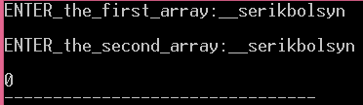

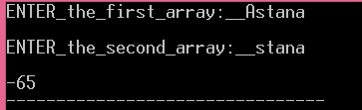

**76.**

#include <iostream>

using namespace std;

int main ()

{

char ans_3598; //repeatition_loop

do

{ int array_3598[10]; //array_declaration;

cout<<"____Please_input_10_numbers_: \n";

for (int i_3598=0; i_3598<10; ++i_3598) //loop_for_input;

{

cin>>array_3598[i_3598];

}

cout<<"Array__is: ";

for (int i_3598=0; i_3598<10; ++i_3598) //loop_for_display_the_array

{

cout<<array_3598[i_3598]<<" ";

}

int num_3598;

cout<<"\nPlease_input_the_value_you_want_to_find: ";

cin>>num_3598;

int n_3598=0; //counts_numbers

for (int z_3598=0; z_3598<10; ++z_3598)

{

if (array_3598[z_3598]==num_3598) //if_it_find_similar_number

{

n_3598=n_3598+1; //counts_for_the_purpose_not_to_display_another_condition

}

}

if (n_3598==0)

{

cout<<num_3598<<"_is_not_in_the_array!\n";

}

else

{

cout<<num_3598<<"_is_in_the_array!\n";

}

cout<<"Would_you_like_to_repeat_trial?"<<endl;

cin>>ans_3598;

cout<<endl;

}

while (ans_3598=='Y' || ans_3598=='y');

return 0;

}

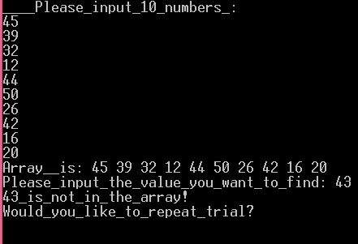

**77.**

#include <iostream>

using namespace std;

int main ()

{

char ans_3598; //repeatition_loop

do

{ int size_3598=0;

int input_3598[size_3598]; //store_the_array;

cout<<"Please_ENTER_how_many_numbers_you_will_input: ";

cin>>size_3598;

for (int i_3598=0; i_3598<size_3598; ++i_3598) //loop_for_array_number;

{ cout<<"Please_ENTER_the_number_"<<i_3598<<": ";

cin>>input_3598[i_3598];

}

for (int z_3598=0; z_3598<size_3598; ++z_3598) //loop_for_display;

{

cout<<input_3598[z_3598]<<" ";

}

cout<<"\nWould_you_like_to_repeat_trial?"<<endl;

cin>>ans_3598;

cout<<endl;

}

while (ans_3598=='Y' || ans_3598=='y');

return 0;

}

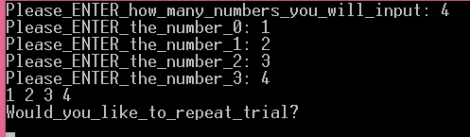

**78.**

#include <iostream>

#include <cstring>

using namespace std;

int main ()

{

char ans_3598; //repeatition_loop

do

{

string input_3598; //here_I_store_string_array;

cout<<"ENTER_THE_WORD:___";

cin>>input_3598;

string b_3598=""; //I-declare_the_reversed_of_the_word

for (int i_3598=0; i_3598<input_3598.length(); ++i_3598) //here_I_define_each_character_of_the_input_and_combine_reversed

{ b_3598=input_3598[i_3598]+b_3598;

}

cout<<b_3598;

cout<<"\nWould_you_like_to_repeat_trial?"<<endl;

cin>>ans_3598;

cout<<endl;

}

while (ans_3598=='Y' || ans_3598=='y');

return 0;

}

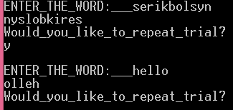

**79.**

#include <iostream>

using namespace std;

int main ()

{char ans_3598; //repeatition_loop

do

{

int num_3598=0; // declaration_of_the_entered_number;

cout<<"The_Fibonacci_Series_starts_from_1!\n";

cout<<"PLEASE_ENTER_THE_NUMBER:___ \n";

cin>>num_3598;

int num_store_3598=num_3598;

int series_3598[num_3598];

cout<<endl;

series_3598[0]=1; //define_first_member;

series_3598[1]=1; //define_second_member;

for (int i_3598=2; i_3598<num_3598+1; ++i_3598) //I_open_the_loop_for_defining_series

{

series_3598[i_3598]=series_3598[i_3598-1]+series_3598[i_3598-2];

}

for (int z_3598=0; z_3598<num_3598; ++z_3598) //this_loop_displays_the_results;

{ cout<<series_3598[z_3598]<<" ";

}

int sum_3598=0; //here_I_declare_the_sum_of_series_to_find_average

for (int z_3598=0; z_3598<num_3598; ++z_3598) //loop_defining_sums

{ sum_3598+=series_3598[z_3598];

}

cout<<"\nTHE_AVERAGE_IS_EQUAL_TO:___"<<sum_3598/num_3598<<endl;

cout<<"\nWould_you_like_to_repeat_trial?"<<endl;

cin>>ans_3598;

cout<<endl;

}

while (ans_3598=='Y' || ans_3598=='y');

return 0;

}

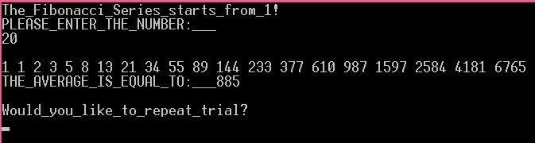

**80.**

#include <iostream>

using namespace std;

int main ()

{char ans_3598; //repeatition_loop

do

{

int size_3598=0;

cout<<"Please_input_how_m@ny_numbers: ";

cin>>size_3598;

int array_3598[size_3598];

for (int i_3598=0; i_3598<size_3598; ++i_3598)

{

cout<<"__Please_input_the_integer_number_for_index_"<<i_3598<<": ";

cin>>array_3598[i_3598];

cout<<endl;

}

for (int z_3598=0; z_3598<size_3598; ++z_3598) //here_I_open_outer_loop;

{

for (int d_3598=0; d_3598<size_3598; ++d_3598) //inner_loop;

{

if (array_3598[d_3598]>array_3598[z_3598])

{

//now_if_the_condition_is_valid_I_change_them

int store_3598;

store_3598=array_3598[z_3598];

array_3598[z_3598]=array_3598[d_3598];

array_3598[d_3598]=store_3598;

}

}

}

cout<<endl<<"The_sorted_array_is_:"<<endl;

for (int x_3598=0; x_3598<size_3598; ++x_3598)

{

cout<<"a["<<x_3598<<"]="<<array_3598[x_3598]<<endl;

}

int n_3598=0;

for (int p_3598=0; p_3598<size_3598; ++p_3598)

{

if (array_3598[p_3598]==p_3598)

{

n_3598=n_3598+1; //counts_the_similarities;

}

}

cout<<"THE_ANSWER_IS: "<<n_3598;

cout<<"\nWould_you_like_to_repeat_trial?"<<endl;

cin>>ans_3598;

cout<<endl;

}

while (ans_3598=='Y' || ans_3598=='y');

return 0;

}

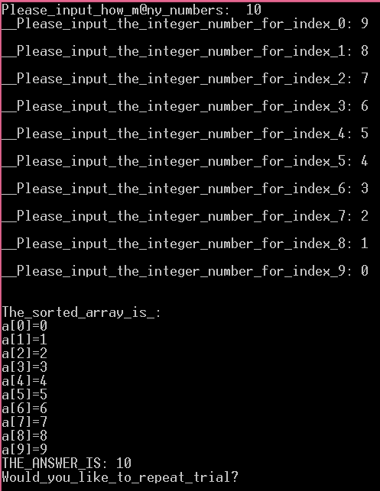

**81.**

#include <iostream>

using namespace std;

int main ()

{char ans_3598; //repeatition_loop

do

{ int size1_3598=0, size2_3598=0; //declare_matrix_dimensions;

cout <<"Please_input_the_matrix_dimensions:_row_numbers_then_column_numbers: ";

cin>>size1_3598; //input_the_row_size;

int store1_3598=size1_3598; //I_store_this_value_again

cin>>size2_3598; //input_column_size;

cout<<endl;

int array_3598[size1_3598][size2_3598]; //here_I_declare_two_dimensional_array;

cout<<"Please_enter_matrix_elements: ";

int sum_3598[size1_3598]; //here_I_declare_array_for_the_row_summation;

for (int i_3598=0; i_3598<size1_3598; ++i_3598) //matrix_input_loops;

{

for (int r_3598=0; r_3598<size2_3598; ++r_3598)

{cin>> array_3598[i_3598][r_3598];}

}

for (int z_3598=0; z_3598<size1_3598; ++z_3598) //loops_for_defining_row_summations;

{

sum_3598[z_3598]=0;

for (int u_3598=0; u_3598<size2_3598; ++u_3598)

{

sum_3598[z_3598]+=array_3598[z_3598][u_3598];}

}

int n_3598=0; //number_of_the_row_with_max_sum

for (int h_3598=0; h_3598<size1_3598; ++h_3598) //defining_row_with_max_sum;

{

int max_row_3598=sum_3598[h_3598];

for (int d_3598=0; d_3598<store1_3598; ++d_3598)

{

if (max_row_3598<sum_3598[d_3598])

{

n_3598=d_3598+1;

}

}}

cout<<"\nThe_row_with_maximum_sum_is: "<<n_3598<<endl;

cout<<"\nWould_you_like_to_repeat_trial?"<<endl;

cin>>ans_3598;

cout<<endl;

}

while (ans_3598=='Y' || ans_3598=='y');

return 0;

}

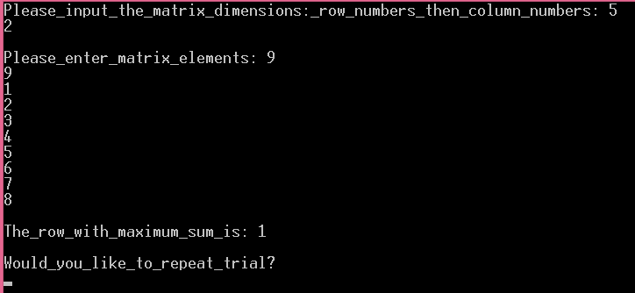

**82.**

#include <iostream>

#include <cstring>

using namespace std;

int main ()

{

char ans_3598; //repeatition_loop

do

{

string input_3598; //here_I_store_string_array;

cout<<"ENTER_THE_WORD:___";

cin>>input_3598;

string b_3598=""; //I-declare_the_reversed_of_the_word

for (int i_3598=0; i_3598<input_3598.length(); ++i_3598) //here_I_define_each_character_of_the_input_and_combine_reversed

{ b_3598=input_3598[i_3598]+b_3598;

}

cout<<b_3598;

cout<<"\nWould_you_like_to_repeat_trial?"<<endl;

cin>>ans_3598;

cout<<endl;

}

while (ans_3598=='Y' || ans_3598=='y');

return 0;

}

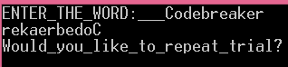

**83.**

#include <iostream>

#include <string>

#include <cctype>

using namespace std;

int main ()

{ char input_3598[32]={0};

cout<<"ENTER_the_string:__";

cin.getline(input_3598, 32);

int n_3598=0, b_3598=0, answer_3598;

for( int i_3598=0; input_3598[i_3598]!='\0'; i_3598++) //loop_which_defines_each_character_and_spaces;

{

//These_condition_check_if_there_are_missed_brackets:

if (input_3598[i_3598]=='(')

{

n_3598=n_3598+1;

}

if (input_3598[i_3598]==')'&& i_3598!=0)

{

b_3598=b_3598+1;

}

}

if (b_3598-n_3598==0) //Conditions_defining_trure_or_false;

{ answer_3598=1;

for( int i_3598=0; input_3598[i_3598]!='\0'; i_3598++) //loop_which_defines_each_character_and_spaces;

{

//Now_I_write_condition_to_check_whether_the_brackets_placed_after_the_operators:

if (input_3598[i_3598]=='+' && input_3598[i_3598+1]==')' )

{

answer_3598=0;

}

if (input_3598[i_3598]='-' && input_3598[i_3598+1]==')' )

{

answer_3598=0;

}

if (input_3598[i_3598]=='/' && input_3598[i_3598+1]==')' )

{

answer_3598=0;

}

if (input_3598[i_3598]=='*' && input_3598[i_3598+1]==')' )

{

answer_3598=0;

}

}

}

else

{

answer_3598=0;

}

cout<<endl<<answer_3598;

return 0;

}

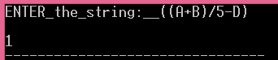

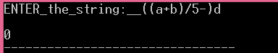

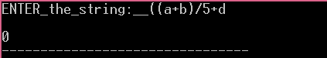

**84.**

#include <iostream>

#include <string>

#include <cctype>

using namespace std;

int main ()

{ char input_3598[32]={0};

cout<<"ENTER_the_string:__";

cin.getline(input_3598, 32);

for( int i_3598=0; input_3598[i_3598]!='\0'; i_3598++) //loop_which_defines_each_character;

{

if (i_3598%2==0 ||i_3598==0)

{

if (std::islower(input_3598[i_3598])) //checks_if_it_is_low

{

cout<<static_cast<char>(std::toupper(input_3598[i_3598]));

}

else

{

cout<<input_3598[i_3598];

}

}

else

{

if (std::isupper(input_3598[i_3598])) //checks_if_it_capital

{

cout<<static_cast<char>(std::tolower(input_3598[i_3598]));

}

else

{

cout<<input_3598[i_3598];

}

}

}

return 0;

}

C:\Users\Admin\AppData\Local\Microsoft\Windows\INetCache\Content.Word\Новый рисунок.bmp

**85.**

#include <iostream>

#include <string>

#include <cctype>

using namespace std;

int main ()

{

char ans_3598; //repeatition_loop

do

{ string input1_3598; //first_string_input;

string input2_3598; //second_string_input;

cout<<"PLEASE_INPUT_THE_FIRST_STRING: ";

cin>>input1_3598;

cout<<endl<<"PLEASE_INPUT_THE_SECOND_STRING: ";

cin>>input2_3598;

if (input1_3598==input2_3598 ) //condition_for_comparison;

{

cout<<endl<<"1";

}

else

{

cout<<endl<<"0";

}

cout<<"\nWould_you_like_to_repeat_trial?"<<endl;

cin>>ans_3598;

cout<<endl;

}

while (ans_3598=='Y' || ans_3598=='y');

return 0;

}

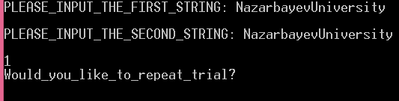

**86.**

#include <iostream>

using namespace std;

int main ()

{

string input_3598; //declarartion_input;

cout<<"Enter_the_text,_please: ";

cin>>input_3598;

cout<<endl;

if (input_3598==string(input_3598.rbegin(), input_3598.rend())) //checks_the_input_with_reversed_input

{

cout<<"1";

}

else

{

cout<<"0";

}

return 0;

}

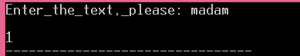

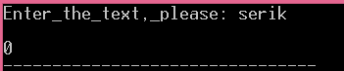

**87.**

#include <iostream>

#include <cctype>

using namespace std;

int main ()

{

string input_3598;

string word_3598; //word_to_define;

cout<<"Enter_the_text,_please: ";

cin>>input_3598;

cout<<endl<<"Enter_the_word_you_want_to_find: ";

cin>>word_3598;

cout<<endl;

//counting_the_place_it_starts;

int index_3598=0;

index_3598=input_3598.find(word_3598);

if (index_3598>0) //for_displaying_the_place

{

cout<<"The_index_of_the_first_character_in_the_second_found_in_first_string: "<<index_3598+1;

}

else //if_not_found:

{

cout<<endl<<"-1";

}

return 0;

}

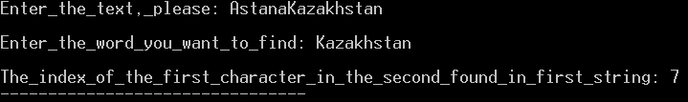

**88.**

#include <iostream>

#include <cstring>

using namespace std;

int main ()

{

char ans_3598; //repeatition_loop

do

{

string input_3598; //here_I_store_string_array;

cout<<"_Input_is:___";

cin>>input_3598;

string b_3598=""; //I-declare_the_reversed_of_the_word

for (int i_3598=0; i_3598<input_3598.length(); ++i_3598) //here_I_define_each_character_of_the_input_and_combine_reversed

{ b_3598=input_3598[i_3598]+b_3598;

}

cout<<"Output_is:___"<<b_3598;

cout<<"\nWould_you_like_to_repeat_trial?"<<endl;

cin>>ans_3598;

cout<<endl;

}

while (ans_3598=='Y' || ans_3598=='y');

return 0;

}

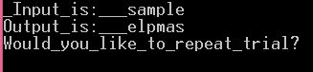

**89.**

#include <iostream>

#include <cctype>

using namespace std;

int main ()

{

string input_3598;

string word_3598; //word_to_define;

cout<<"Enter_the_text,_please: ";

cin>>input_3598;

cout<<endl<<"Enter_the_word_you_want_to_find: ";

cin>>word_3598;

cout<<endl;

//counting_the_place_it_starts;

int index_3598=0;

index_3598=input_3598.find(word_3598);

if (index_3598>0) //for_displaying_the_place

{

cout<<index_3598+1;

}

else //if_not_found:

{

cout<<endl<<"The_string_was_not_found!";

}

return 0;

}

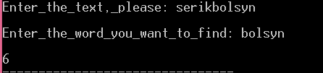

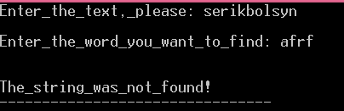

**90.**

#include <iostream>

#include <cctype>

using namespace std;

int main ()

{

char input_3598[50]={0};

cout<<"ENTER_the_text:__";

cin.getline(input_3598, 50);

int sum_3598=0;

int ch_value_3598=0; //declare_decimal_equivalent;

char ch_3598={0};

for( int i_3598=0; input_3598[i_3598]!='\0'; i_3598++) //

{

ch_value_3598=input_3598[i_3598]; //convert_the_character_to_ASCII;

sum_3598+=ch_value_3598;

}

cout<<"The_decrypted_string_value_is: "<<sum_3598;

return 0;

}

C:\Users\Admin\AppData\Local\Microsoft\Windows\INetCache\Content.Word\Новый рисунок.bmp

**91.**

#include <iostream>

#include <cctype>

using namespace std;

int main ()

{

char input_3598[50]={0};

cout<<"ENTER_the_text:__";

cin.getline(input_3598, 50);

int ch_value_3598=0; //declare_decimal_equivalent;

char ch_3598={0};

for( int i_3598=0; input_3598[i_3598]!='\0'; i_3598++) //

{

ch_value_3598=input_3598[i_3598]; //convert_the_character_to_ASCII;

if (input_3598[i_3598]!='z'|| input_3598[i_3598]!='Z') //if_the_character_is_z_it_remains_so;

{

ch_3598=ch_value_3598+1; //conversion_back;

}

else

{

ch_3598=ch_value_3598;

}

cout<<ch_3598;

}

return 0;

}

C:\Users\Admin\AppData\Local\Microsoft\Windows\INetCache\Content.Word\Новый рисунок.bmp

**92.**

#include <iostream>

#include <string>

#include <cctype>

using namespace std;

int main ()

{

char ans_3598; //repeatition_loop

do

{ string input1_3598; //first_string_input;

string input2_3598; //second_string_input;

cout<<"PLEASE_INPUT_THE_FIRST_STRING: ";

cin>>input1_3598;

cout<<endl<<"PLEASE_INPUT_THE_SECOND_STRING: ";

cin>>input2_3598;

if (input1_3598==input2_3598 ) //condition_for_comparison;

{

cout<<endl<<"EQUAL!__";

}

else

{

cout<<endl<<"NOT_EQUAL!__";

}

cout<<"\nWould_you_like_to_repeat_trial?"<<endl;

cin>>ans_3598;

cout<<endl;

}

while (ans_3598=='Y' || ans_3598=='y');

return 0;

}

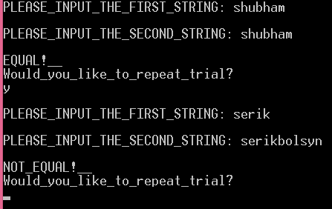

**93.**

#include <iostream>

#include <string>

#include <cctype>

using namespace std;

int main ()

{

char ans_3598; //repeatition_loop

do

{ char input_3598[32]={0};

cout<<"ENTER_the_string:__";

cin.getline(input_3598, 32);

for( int i_3598=0; input_3598[i_3598]!='\0'; i_3598++) //loop_which_defines_each_character_and_spaces;

{

cout<<input_3598[i_3598];

if (input_3598[i_3598]==' ')

{

cout<<endl;

}

}

cout<<"\nWould_you_like_to_repeat_trial?"<<endl;

cin>>ans_3598;

cout<<endl;

}

while (ans_3598=='Y' || ans_3598=='y');

return 0;

}

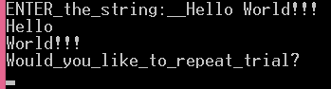

**94.**

#include <iostream>

#include <cctype>

using namespace std;

int main ()

{

char ans_3598; //repeatition_loop

do

{ char input_3598[50]={0};

cout<<"ENTER_the_text:__";

cin.getline(input_3598, 50);

int ch_value_3598=0; //declare_decimal_equivalent;

int a_3598=0, b_3598=0,c_3598=0, d_3598=0, e_3598=0, f_3598=0, g_3598=0, h_3598=0; //declaration_of_the_binary_equivalent;

cout<<endl<<"The_binary_equivalent_is:_ ";

for( int i_3598=0; input_3598[i_3598]!='\0'; i_3598++) //

{

ch_value_3598=input_3598[i_3598];

a_3598=ch_value_3598%2;

ch_value_3598=ch_value_3598/2;

b_3598= ch_value_3598%2;

ch_value_3598=ch_value_3598/2;

c_3598=ch_value_3598%2;

ch_value_3598=ch_value_3598/2;

d_3598=ch_value_3598%2;

ch_value_3598=ch_value_3598/2;

e_3598=ch_value_3598%2;

ch_value_3598=ch_value_3598/2;

f_3598=ch_value_3598%2;

ch_value_3598=ch_value_3598/2;

g_3598=ch_value_3598%2;

ch_value_3598=ch_value_3598/2;

h_3598=ch_value_3598%2;

cout<<h_3598<<g_3598<<f_3598<<e_3598<<d_3598<<c_3598<<b_3598<<a_3598<<" ";

}

cout<<"\nWould_you_like_to_repeat_trial?"<<endl;

cin>>ans_3598;

cout<<endl;

}

while (ans_3598=='Y' || ans_3598=='y');

return 0;

}

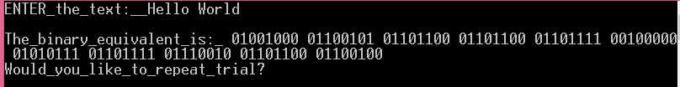

**95.**

#include <iostream>

#include <string>

using namespace std;

int main ()

{

char ans_3598; //repeatition_loop

do

{ string input_3598; //Dellaration_of_the_input_text;

cout<<"Please_enter_the_n@me:__";

cin>>input_3598;

cout<<endl;

//here_I_write_the_condition_for_mitchell:

if (input_3598=="Mitchell" || input_3598=="mitchell")

{

for( int i_3598=0; i_3598<5; i_3598++) //loop_for_repeatition;

{

cout<<input_3598<<endl;

}

}

else

{

for( int i_3598=0; i_3598<10; i_3598++) //loop_for_repeatition;

{

cout<<input_3598<<endl;

}

}

cout<<"\nWould_you_like_to_repeat_trial?"<<endl;

cin>>ans_3598;

cout<<endl;

}

while (ans_3598=='Y' || ans_3598=='y');

return 0;

}

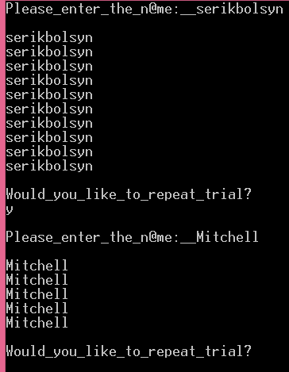

**96.**

#include <iostream>

#include <cctype>

using namespace std;

int main ()

{

char ans_3598; //repeatition_loop

do

{ char input_3598[100]={0};

cout<<"ENTER_the_text:__";

cin.getline(input_3598, 100);

int vow_3598=0; //declearation_of_vowels_number;

for( int i_3598=0; input_3598[i_3598]!='\0'; i_3598++) //loop_for_counting_vowels;

{

if (std::isalpha(input_3598[i_3598])) //includes_only_letters_for_count

{ switch (std::tolower(input_3598[i_3598])) {

case 'a': case 'u': case'i': case 'e' : case'o':

vow_3598=vow_3598+1; //vowels_count;

break;

}

}

}

cout<<endl<<"This_text_contains "<<vow_3598<<"_vowels_"<<endl;

cout<<"\nWould_you_like_to_repeat_trial?"<<endl;

cin>>ans_3598;

cout<<endl;

}

while (ans_3598=='Y' || ans_3598=='y');

return 0;

}

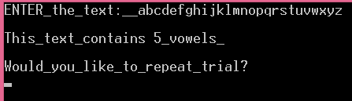

**97.**

#include <iostream>

#include <string>

using namespace std;

int main ()

{

char ans_3598; //repeatition_loop

do

{ string input_3598; //Dellaration_of_the_input_text;

cout<<"Please,_enter_the_text_terminated_by_0:__";

std::getline(cin, input_3598, '0');

string word_3598; //the_word_which_will_be_replaced;

cout<<"\nEnter_the_word_you_want_to_replace:__";

cin>>word_3598;

string new_word_3598; //the_replacement_word;

cout<<"\nEnter_the_word_for_which_you_want_to_replace:__";

cin>>new_word_3598;

if (word_3598==new_word_3598)

{

cout<<"\nThe_nreplacement_word_is_the_same_with_initial_word!";

}

size_t start = input_3598.find(word_3598);

while (start!=string::npos){

input_3598.replace(start, word_3598.length(), new_word_3598); //replacing_the_word;

start=input_3598.find(word_3598, start+new_word_3598.length());}

cout<<endl<<"Replaced_new_input_text_is: "<<input_3598<<endl;

cout<<"\nWould_you_like_to_repeat_trial?"<<endl;

cin>>ans_3598;

cout<<endl;

}

while (ans_3598=='Y' || ans_3598=='y');

return 0;

}

